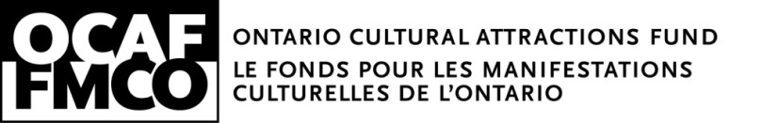

Stage 1 Application
Instructions for Stage 1 Application

Application Process

All applicants will receive written notice, by mail or e-mail, confirming receipt of their stage 1 application.
If your organization's stage 1 application demonstrates basic project qualifications consistent with Ontario Cultural Attractions Fund (OCAF) objectives, you will be invited to complete a detailed stage 2 application.

Stage 2 applications will not be considered unless a stage 1 application has been reviewed and, in the opinion of the Ontario Cultural Attractions Fund, qualifies for consideration for OCAF funding.

The invitation to submit a stage 2 application, and the submission of a stage 2 application form does not guarantee that a project will receive OCAF funding. Funding approval is subject to consideration by staff and the Ontario Cultural Attractions Fund board of directors. Each applicant approved for OCAF funding will be required to execute a legal agreement with the Ontario Cultural Attractions Fund that sets out repayment requirements.

Eligibility

In order to be considered for OCAF funding, an organization must be an incorporated Ontario-based, not-for-profit and/or charitable professional arts, heritage or cultural organization, whose primary purpose is the presentation of arts, heritage or other cultural programming, or the preservation and presentation of arts and heritage resources in Ontario; or an Ontario municipality or municipal agency that is undertaking a major project in the arts or heritage sector.

Eligible organizations must have been in existence for at least one year and be in compliance with the financial reporting requirements under the Corporations Act (See details and conditions of applicability in the Program Guidelines.)

Applicants may receive OCAF support no more than once every two years. (See details and conditions of applicability in the Program Guidelines.)

Eligible projects must be one-time only and/or be demonstrably distinct from the ongoing programming or activity of the applicant (this could be a significant expansion or enhancement to existing programming.) The project submitted must represent the single largest new programming initiative in the applicant’s business plan for that year. The project must aim to make a measurable contribution to the profile, future attendance and revenue generating potential of the applicant.

Form Instructions

Applications may be mailed, e-mailed or faxed. Original signatures are required for the file. Multiple copies are not required.

Section 2. Project Description:

- Project description. Please include key information about the project, including programming, location, schedule of events, and key participants as well as the goals of the project.

- Project distinctiveness. Briefly demonstrate that your project is distinct from your organization regular/ongoing programming. Please include quantitative and qualitative details if the project is a significant expansion or enhancement to existing programming

- Target market. The OCAF mandate is to support cultural activity that has the potential to attract new visitors to a community. Applications targeting out of province and/or international visitors will be assigned a higher priority in the assessment process. The Ministry of Tourism defines a tourist as someone traveling from within Ontario a distance of 40 kilometers or more, or from elsewhere in Canada 80 kilometers or more.

Section 3. Budget:

1. Line A (earned revenue) must represent at least 40% of total project revenues (unless your project is considered free or low-cost in which case The sum of lines A plus B (earned revenue plus private sector support and/or private sector sponsorship) must represent at least 50% of total project revenues..

2. Line B (private support and/or private sector sponsorship) must represent at least 10% of total project revenues. The majority of this line item must be cash with the balance made up of in kind support that is quantifiable and reasonably valued.

3. The sum of lines A plus B (earned revenue plus private sector support and/or private sector sponsorship) must represent at least 50% of total project revenues.

4. Line E (request for OCAF investment) must take into account the benchmarks mentioned in the program guidelines.

5. Line G must include production and marketing. Make sure you state your projected marketing and promotion projected expenses.

6. Line H (net project income) should enable the organization to repay a portion of the OCAF investment and generate net income for the organization.

Repayment

Organizations receiving OCAF support are required to contribute 15% of project earned revenues back into the Fund, up to the maximums (see program guidelines). In some cases, repayment will be guaranteed at the maximums.

The Ontario Cultural Attractions Fund is a program of the Government of Ontario through the Ministry of Heritage, Sport, Tourism and Culture Industries and administered by the Ontario Cultural Attractions Fund Corporation.

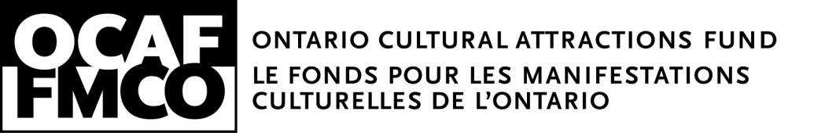
Stage 1 Application Form

Please read the Cultural Attractions Fund Program Guide and Stage 1 Instructions before completing this form.

1. Organizational Information

Organization name:
Street address:
City: |  |  | Province: ON |  | Postal code:
Telephone: |  |  | Fax:
Email address:
Website:
Name, title, and email of head of programming:
Name, title, and email of head of organization:
Name, title, and email of head of board:
Name, title, and email of contact person:
Day-time contact telephone number:
Is your organization incorporated as a not-for-profit corporation?
 | Incorporation number: |  |  | Date of incorporation:
 | Jurisdiction of incorporation:
 | Charitable organization registration number:
Does your organization have audited financial statements?
 | Annual operating revenues (last audited):
 | Most recent year accumulated surplus / (deficit):
Mandate of the organization (2 sentences):

2. Project Description

Name of Project:
Start date: |  |  | End date:
Location:
Projected paid attendance: |  |  | Projected free attendance:
Last year’s (or previous) attendance (for same period):
Attach a separate sheet answering the following questions:

- Briefly describe the proposed project.
- Briefly describe how the project is distinct from your organization’s regular programming.
- Whom is the project intended to attract in your community i.e. what is the target market?

3. Budget

A. Earned project revenue* (e.g., admissions, merchandising, food and beverage sales): | $
B. Private support and/or private sector sponsorship*  (in-kind must be reasonably valued): | $
C. Support from other government (e.g., federal/municipal) | $
D. Contribution from host organization(s) if applicable: | $
E. Request for OCAF investment: | $
F. Gross revenues (A+B+C+D+E): | $
G. Total expenses  including promotion and marketing expenses of $ | $
H. ESTIMATED NET INCOME (F - G): | $
REPAYMENT CAPACITY:  I. Estimated earned project revenue (line A multiplied by 15%):  J. Estimated OCAF repayment capacity (line I divided by line E): | $  %
* Must total required amounts. Please see Stage 1 Instructions for further information.

4. Program Requirements

Please answer ‘Yes’ or ‘No’ to each of the following questions.
A ‘Yes’ answer in every case indicates that your project is eligible for consideration
 |  |  | YES | NO
1. | Is the amount entered in line A greater than, or equal to, 40% of the amount  entered in line F?
If you answered NO to the question 1 AND your event is free or low-cost:
Is the sum of lines A and B greater than or equal to 50% of the amount in line F?
2. | Is the amount in line J approximately equal to the target repayment requirements  as mentioned in the program guide?
3. | Does this project constitutes the largest new programming initiative for your  organization this year?
4. | Is this a one-time only project and/or be demonstrably distinct from the ongoing programming or activity of the applicant AND with planned opening and closing dates?
5. | Will new visitors come to your community for the primary purpose of experiencing  this cultural attraction?

Signature of Authorized Signing Officer |  | Name (Print) |  | Date

Please send completed form to:

Thomas Vaughan
Associate Director
Ontario Cultural Attractions Fund
tvaughan@ocaf.ca
416-969-7449│1-877-386-8029

